 | Monday | Tuesday | Wednesday | Thursday | Friday
Literacy | Sylvie by Jennifer Sattler | Recycle Every Day by Nancy Elizabeth Wallace | Trashy Town by Steven Kroll | Stuff! Reduce, Reuse, Recycle  by Andrea Zimmerman | The Lorax by Dr. Seuss
Art | Handprint Pink Flamingos | Free Art | Junk Mail Jewels | Paper baskets from newspaper | Truffela Trees
Math | Recycling Cans  Kool Aid Graph | Paper Airplanes distance measuring | Pollution Pond | Measuring the Sandbox | Recycled Can count
Science | Which Pink Kool-aid tastes best? | What is biodegradable? | Trash collecting | Earth Day Bracelet nature walk | 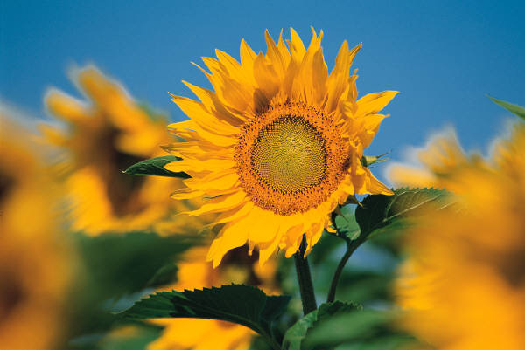
Language/Dramatic Play | Kindermusic | Set up Recycling Center- Paper, metal, plastic  Let’s Recycle song | “Pick it Up” song | Garage Sale with play money | Kozy Heart Garden Party

Earth day bracelt: http://www.everythingpreschool.com/themes/earthday/art.htm

Pollution Pond: http://www.everythingpreschool.com/themes/earthday/science.htm

